
MINISTRY OF EDUCATION AND TRAINING

FPT UNIVERSITY

Capstone Project Document
Build a website provide service for delivering meal designed and prepared by talent chefs to customer

Group 6
Group Members | Nguyễn Thành Nhân – Leader – SE60677  Lê Quang Khương Duy – Member – SE60752  Trương Quang Bảo – Member – 60575  Phạm Văn Duy – Member – SE60634
Supervisor | Lâm Hữu Khánh Phương
Ext Supervisor | N/A
Capstone Project code | EWC

Ho Chi Minh, 01/2014
Table of Content

2. Project Management Plan: 2
2.1. Problem Definition: 2
2.1.1. Name of this Capstone Project: 2
2.1.2. Problem Abstract: 3
2.1.3. Project Overview: 3
2.1.3.1. The current system: 3
2.1.3.2. The proposed system: 3
2.1.3.3. Boudaries of the System: 3
2.1.3.4. Development Environment: 3
2.2. Project Organization: 3
2.2.1. System process Model: 3
2.2.2. Roles and Responsibility: 4
2.2.3. Tools and techniques: 5
2.3. Project Management Plan: 5
2.3.1. Tasks 6
2.3.1.1. Business Analysis 6
2.3.1.2. Project planning 6
2.3.1.3. Software Requirement Specification 6
2.3.1.4. Prepare test case 6
2.3.1.5. System Architecture Design 6
2.3.1.6. Project developing 7
2.3.1.7. Testing and fix bug 7
2.3.2. Task Sheet 7
2.3.3. All Meeting Minutes 7
2.4. Convention Rules 7

2. Project Management Plan

2.1. Problem Definition:

2.1.1. Name of this Capstone Project:
English: Build a website provide service for delivering meals designed and prepared by talented chefs to customers.
Vietnamese: Xây dựng website cung cấp các món ăn được thiết kế và nấu bởi các đầu bếp đến khách hàng.

2.1.2. Problem Abstract:
This system shows the information about local talent chef and their meals for customer to booking. Some condition about time for booking, preparing and delivering are detailed later.
Customer can search dish with simple search and advance search, add dish to their cart and check out with payment online method.
Customer can check dishes’ ingredient traceability by scan QR code.
System supports company manage dish cooking and delivering process with can assign dish for order bills.

2.1.3. Project Overview:

2.1.3.1. The current system:
There are no current system support food traceability and provide food design and prepared by local talent chef. But, there are some food online systems provide foods by number of restaurants such as: http://www.vietnammm.com/, http://hotmeal.vn/, http://chonmon.vn/ …

2.1.3.2. The proposed system:
System support customer view information of local talent chef, order dish and payment online.
System support admin can create chef, manage ingredient tracibility, and manage order and delivery.
With chef role user can create and manage dish that they design and prepare.

2.1.3.3. Boudaries of the System:
System intended for give information about local talent chef and their meal. Allow customer order and payment online.
System intended support manage order process and cooking process. Give information about ingredient that customer can trace the original.
The language of system is Vietnamese.
The complete product includes:
- Website show chef information and daily menu allow user to explore, order and payment online.
- Admin dashboard for administrator and staff to manage and interact with customer.
- All project documents and design.

2.1.3.4. Development Environment:
Microsoft .NET Framework 4.5

2.2. Project Organization:

2.2.1. System process Model:
The model used for developing this project is Scrum model.
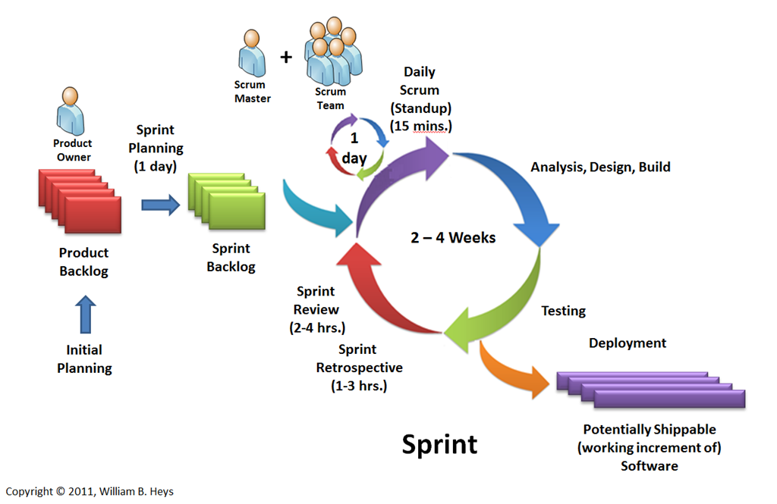
Figure 2-1 Scrum model

2.2.2. Roles and Responsibility:
Full name | Role in group | Responsibilities
Lâm Hữu Khánh Phương | Product Owner | - Clearly expressing Product Backlog items.  - Ordering the items in the Product Backlog to best achieve goals and missions.  - Optimizing the value of the work the Development Team performs.  - Ensuring the Development Team understands items in the Product Backlog to the level needed.
Nguyễn Thành Nhân | Scrum Master, Development Team member, Tester, QA | - Creating software process model.  - Planning Scrum implementations.  - Helping the Scrum Team understand the need for clear and concise Product Backlog items.  - Design database.  - Create system architecture design.  - Support technique.  - Create product Increment.  - Code.  - Test.  - Control Project quality assurance.  - Write document and reports.
Lê Quang Khương Duy | Development Team member, Tester | - Create system use case.  - Support technique.  - Create product Increment.  - Code.  - Test.  - Write document and reports.
Trương Quang Bảo | Development Team member, Tester | - Create product Increment.  - Code.  - Test.  - Write document and reports.
Phạm Văn Duy | Development Team member, Tester | - Create product Increment.  - Code.  - Test.  - Write document and reports.

2.2.3. Tools and techniques:
- Front-end technologies: HTML5, CSS3, JavaScript, jQuery, AJAX.
- Back-end: ASP .NET MVC4, Entity Framework.
- Database development tool: SQL Server 2008.
- Coding tool: Visual Studio 2012
- System design: Software Ideas Modeler
- Process and code tracking: Team Foundation Server.

2.3. Project Management Plan:
- This project will finished in 7 sprints, each sprint lasts for 2 weeks.
- Sprint planning from 8h00 to 11h00 on first Monday of every sprint.
- Daily scrum meeting is held every day at 8h00.
- Sprint review meeting is at 9h00 on last Friday of every sprint.

2.3.1. Tasks

2.3.1.1. Business Analysis
- Description: Analyze basic E-commerce concept, how about special in food. Analyze cooking, ingredient traceability, delivery process, time business condition for booking, producing, and delivering.
- Deliverables: System Overview, Function list.
- Resources Needed: User requirement, marketing research, current system comparison.
- Dependencies and Constraints: N/A
- Risks: Missing user requirement.

2.3.1.2. Project planning
- Description: Project manager and Team Leader create Gannt chart assign task for team members, estimate cost, prepare test plan.
- Deliverables: Task sheet: Assignments and Timetable.
- Resources Needed: Business analysis, function list, resource list.
- Dependencies and Constraints: N/A.
- Risks: error function priority.

2.3.1.3. Software Requirement Specification
- Description: Create software requirement specification based on user requirement description, business analysis.
- Deliverables: Software requirement specification document.
- Resources Needed: User requirement description, business analysis, function list.
- Dependencies and Constraints: N/A
- Risks: Missing user requirement, conflict in understanding user.

2.3.1.4. Prepare test case
- Description: Prepare system test case for each functional requirement in Software requirement specification document, unit test case for each module in function list.
- Deliverables: System test case, unit test case.
- Resources Needed: Software requirement specification document, function list.
- Dependencies and Constraints: N/A
- Risks: Missing test case.

2.3.1.5. System Architecture Design
- Description: Team leader define project architecture design base on design pattern and frameworks.
- Deliverables: Software design document.
- Resources Needed: Software requirement specification.
- Dependencies and Constraints: N/A.
- Risks: N/A.

2.3.1.6. Project developing
- Description: Develop system module, developer perform unit test when finish their module task.
- Deliverables: Code package.
- Resources Needed: Software requirement specification, software design.
- Dependencies and Constraints: N/A
- Risks: Developer lack of experiences, requirement change.

2.3.1.7. Testing and fix bug
- Description: Perform system test base on system test case.
- Deliverables: Test result.
- Resources Needed: Software requirement specification, system test case.
- Dependencies and Constraints: N/A
- Risks: Missing test case, requirement change.

2.3.2. Task Sheet
Refer to Tasksheet.doc document.

2.3.3. All Meeting Minutes
Refer to Meeting Minutes folder.

2.4. Convention Rules
Summary:
- Naming Convention.
- Indentation.
- Declaration.
- Code Examples
Follow “Code Conventions for the C# Programming Language, by Microsoft
http://msdn.microsoft.com/en-us/library/ff926074.aspx

